*Florida International University*

*School of Computing and Information Sciences*

Software Engineering Focus

Feature Document

User Story ID 696

**Name:** Sub-Users List Page

**Team Member(s):** Leandro Gonzalez,Luis Herrnsdorf

**Project:** Smart Stormwater (Smart City System) 2.0

**Product Owner(s)**: Emilio Lopez

**Mentor(s)**:

**Instructor**: Masoud Sadjadi

**User Story Name:** Sub-Users List Page

* Description: As an Admin, I want to be able to have a Sub-Users page where I can create a new sub-user and view all the existing sub-users, so that I can be able to modify their information

Acceptance Criteria

* The page is accessible from other parts of the website
* All immediate sub-users of the user logged in will be listed
* There will be a button that can send the user to modify a sub-user’s information

**Use Case**

* Name: List all sub-users
* Actor: Admin, System
* Preconditions: Admin is logged in
* Description: Admin clicks on the ‘Users’ tab on the main page. The admin is redirected to a page containing a table that lists all of his/her sub-users (users created by the admin). The table displays the sub-users first name, last name, department, role, and username. User can click on a ‘Edit’ button to modify a sub-users information

**Use Case Diagram**

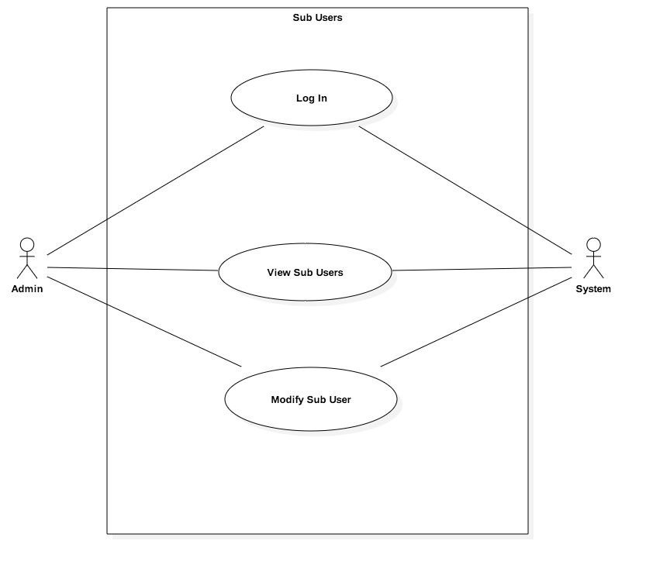

**Sequence Diagram**

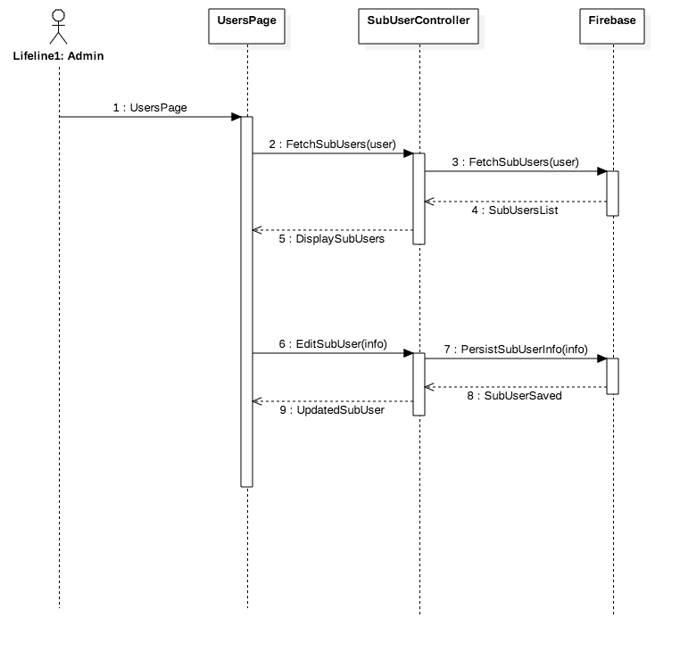

**Class Diagram**

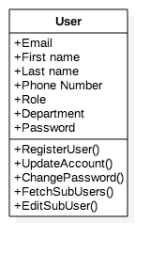

**Unit Test**

* Test case ID: SubUsers001
* Description/Summary of Test: Admin clicks on Users tab to access a list of all of his/her sub-users, from there he/she can add new users, or click a button to modify them
* Pre-condition: Admin is logged in
* Expected Results: The admin sees a list containing all of his/her sub-users
* Actual Result: The admin sees a list containing all of his/her sub-users
* Status (Fail/Pass): Pass

**Visual User Guide**

